PROBABILITY AND
STATISTICS

PS LAB 1,2
#CODE
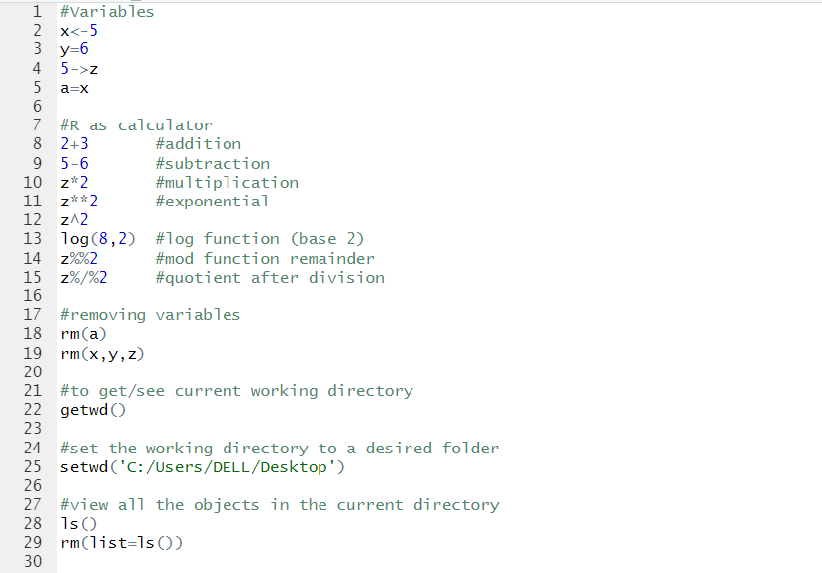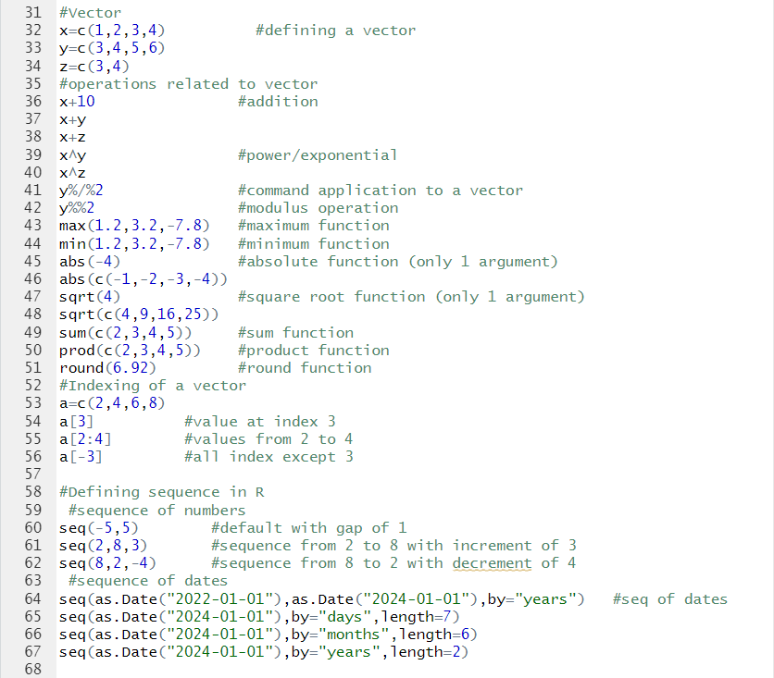

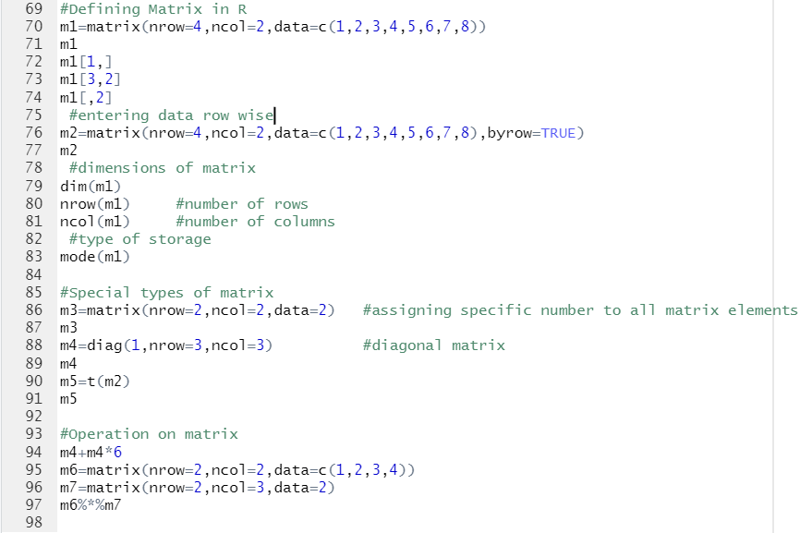
#OUTPUT
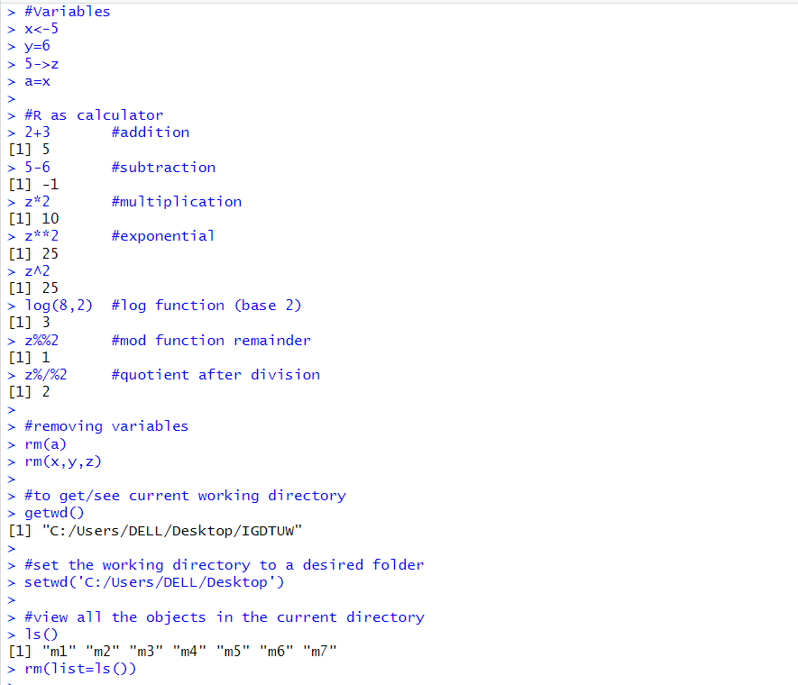

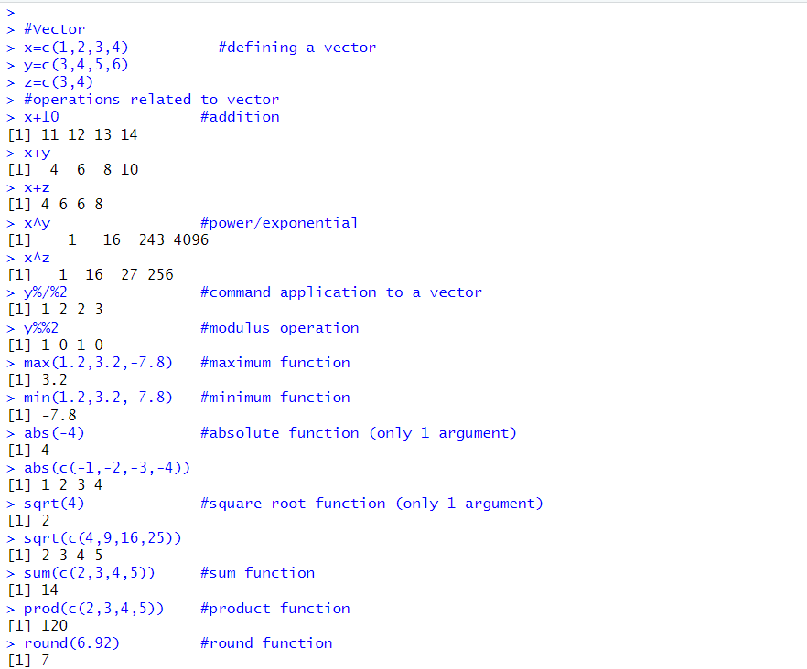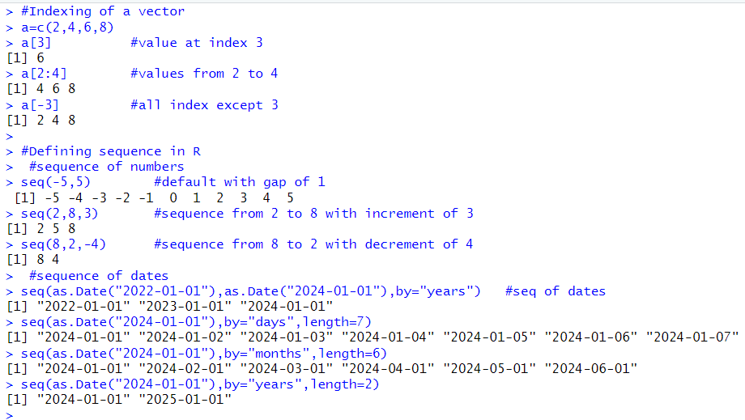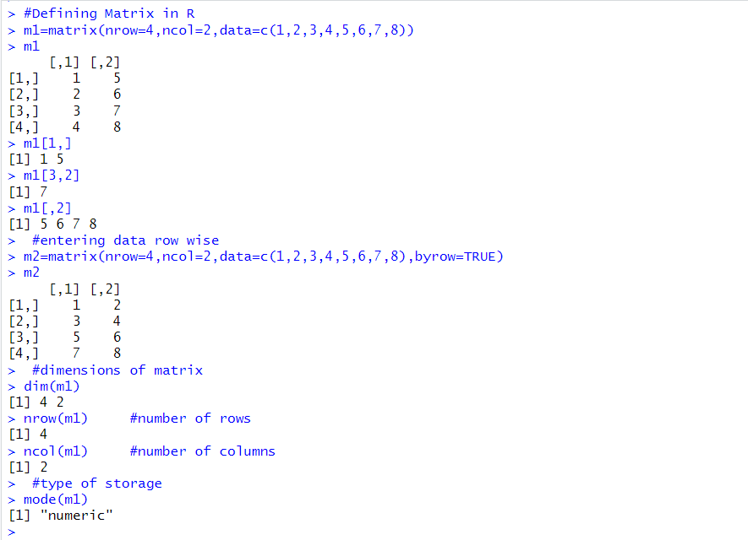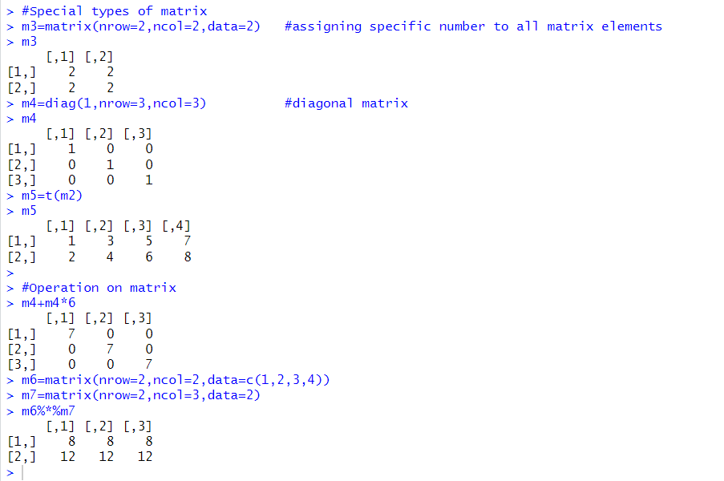

#CODE
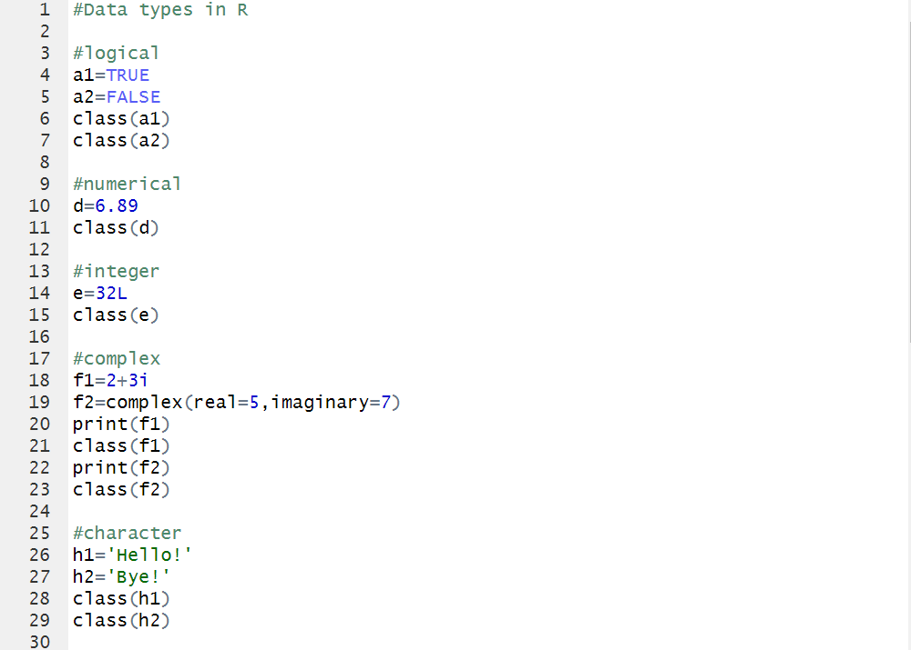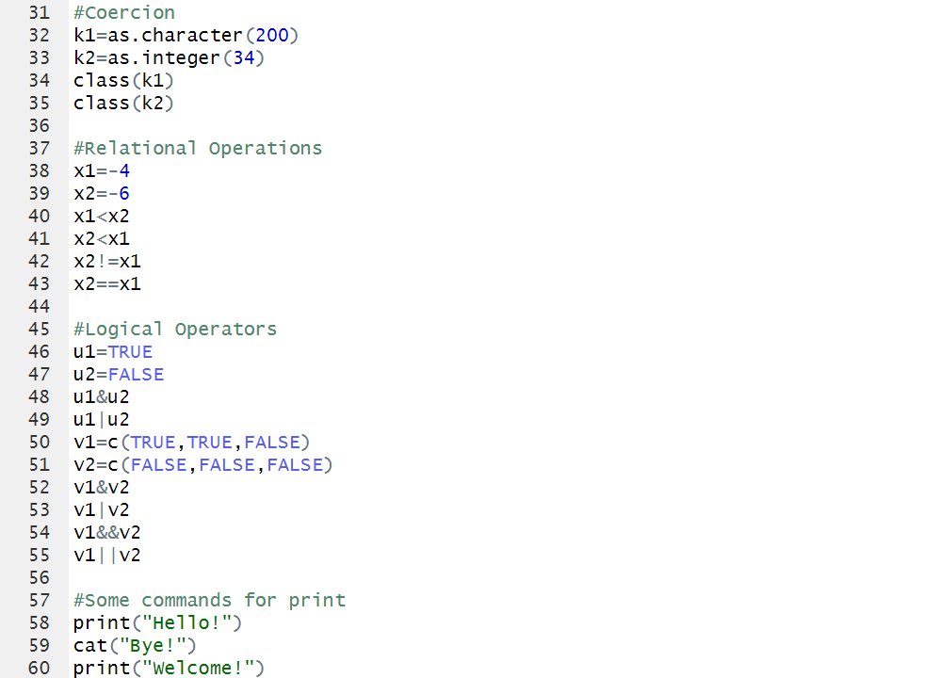
#OUTPUT
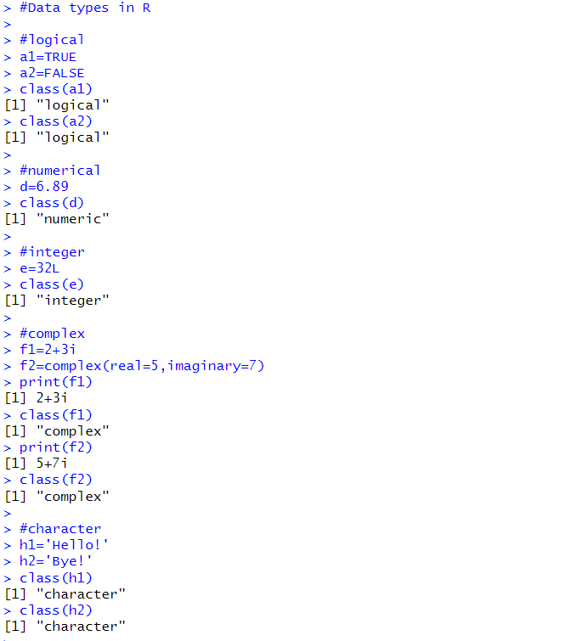
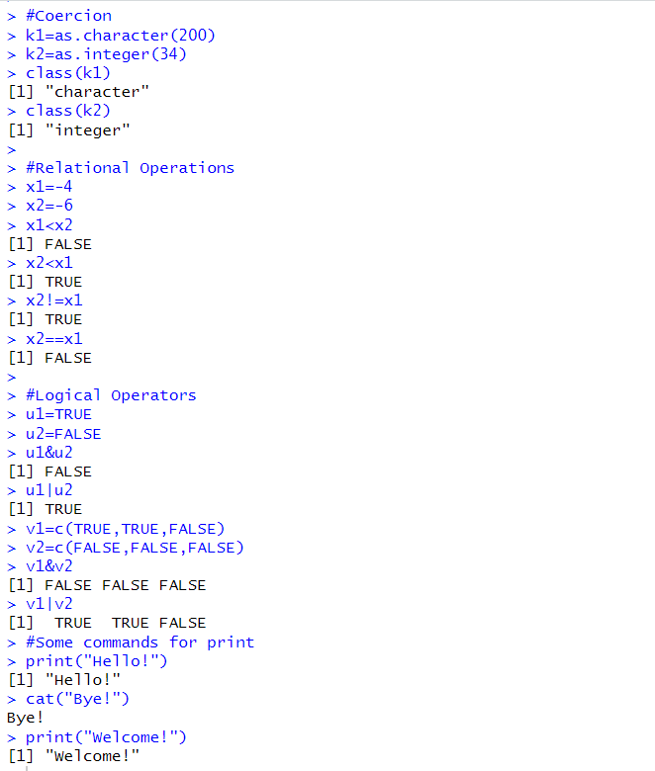

PRACTICAL 1
> #CREATING DATAFRAME
> df=data.frame(Name=c('John','Anna','Peter','Linda'),
+ Age=c(28,24,35,32),
+ Country=c('USA','UK','Australia','Germany'))
> df
Name Age Country
1 John 28 USA
2 Anna 24 UK
3 Peter 35 Australia
4 Linda 32 Germany
>
> #ACCESSING DATA IN DATAFRAMES
> print(df)
Name Age Country
1 John 28 USA
2 Anna 24 UK
3 Peter 35 Australia
4 Linda 32 Germany
> df$Name
[1] "John" "Anna" "Peter" "Linda"
> df[["Name"]]
[1] "John" "Anna" "Peter" "Linda"
> df[,3]
[1] "USA" "UK" "Australia" "Germany"
>
> #ADDING W COLUMN IN DATA FRAME
> df$Weight=c(76,65,58,65)
>
> #ADDING NEW ROW IN DATA FRAME
> df[nrow(df)+1,]=c("Rahul",30,"India",68)
> df
Name Age Country Weight
1 John 28 USA 76
2 Anna 24 UK 65
3 Peter 35 Australia 58
4 Linda 32 Germany 65
5 Rahul 30 India 68
>
> #DELETING ENTRU FROM DATAFRAE
> df$country=NULL
> df
Name Age Country Weight
1 John 28 USA 76
2 Anna 24 UK 65
3 Peter 35 Australia 58
4 Linda 32 Germany 65
5 Rahul 30 India 68
>
> #COMPLETE DESCRIPTIVE STATAUS FROM DATA FRAME
> summary(df)
Name Age Country
Length:5 Length:5 Length:5
Class :character Class :character Class :character
Mode :character Mode :character Mode :character
Weight
Length:5
Class :character
Mode :character
>
> #CHANGE TYPE FROM CHARACTER TO NUMERIC
> df$Age=as.numeric(df$Age)
> #FINDING MEAN
>
> df=data.frame(x,f,prod=x*f)
> df
x f prod
1 0 8 0
2 1 11 11
3 2 5 10
4 3 1 3
> mean=sum(df$prod)/sum(df$f)
>
>
> #WRITING AND READING DATA IN R
>
> getwd() #to get current directory
[1] "C:/Users/DELL/Desktop"
> setwd("C:\Users\DELL\Desktop\PS Lab") #set the working folder to desired folder

> #WRITING CSV
> df=data.frame(Name=c('John','Anna','Peter','Linda'),
+ Age=c(28,24,35,32),
+ Country=c('USA','UK','Australia','Germany'))
> write.csv(df,"employee.csv",row.names=FALSE)
>
> #READING CSV
> data1=read.csv("employee.csv")
> data1
Name Age Country
1 John 28 USA
2 Anna 24 UK
3 Peter 35 Australia
4 Linda 32 Germany
> class(data1$employee) #datatype of employee
[1] "NULL"
>
> #READ DATA FROM THE INTERNET
> data3=read.csv("https://support.staffbase.com/hc/en-us/articles/360007108391-CSV-File-Examples")
> dim(data3)
[1] 1092 1
>
> nrow(data3) #no. of rows
[1] 1092
> ncol(data3) #no. of columns
[1] 1
> length(data3) #no. of coloumns
[1] 1
> dim(data3) #dimesions of data frame by rows and coloumns
[1] 1092 1
> colnames(data3) #shows name of each column
[1] "X..DOCTYPE.html."
> head(data3) #first six entries of data
X..DOCTYPE.html.
1 <html dir=ltr lang=en-US>
2 <head>
3 <meta charset=utf-8 />
4 <!-- v25138 -->
5 <title>CSV File Examples &ndash; Staffbase Support Portal</title>
6
> tail(data3) #last six entries of data

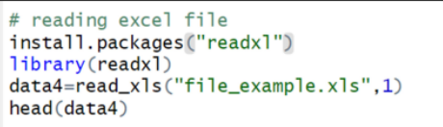

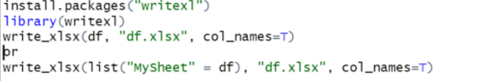
PRACTICAL 2
> #MEASURE OF CENTRAL TENDENCY
> data=c(4,7,9,3,6,5,8,10,4,7,3,8)
> #Mean
> mean(data)
[1] 6.166667
> #Median
> median(data)
[1] 6.5
>
> table(data) #to conunt frequency of each value and put it in tabular form
data
3 4 5 6 7 8 9 10
2 2 1 1 2 2 1 1
>
> #Mode
> mode=function(d){
+ freq=table(d)
+ modes=names(freq[which(freq==max(freq))])
+ cat(modes)
+ }
>
> mode(data)
3 4 7 8> Mode=mode(data)
3 4 7 8> class(Mode)
[1] "NULL"
> Mode=as.numeric(Mode) #converting mode to numeric data type
>
> #max() to specify whether missing values (NA) should be removed before the calculation is performed in R
> mean(c(3,5,NA,6),na.rm=T)
[1] 4.666667
>
> #Variance
> var(data)
[1] 5.606061
> #Standard deviation
> sd(data)
[1] 2.367712
>
> #Minimum,Maximum,Range or Complete descriptive status
> min(data)
[1] 3
> max(data)
[1] 10
> range(data)
[1] 3 10
> summary(data)
Min. 1st Qu. Median Mean 3rd Qu. Max.
3.000 4.000 6.500 6.167 8.000 10.000

#PRACTICE QUESTIONS

ages=c(18,19,19,19,19,20,20,20,20,20,21,21,21,21,22,23,24,27,30,36)
> mean(ages)
[1] 22
> median(ages)
[1] 20.5
> mean(ages[ages<25])
[1] 20.41176
> mode(ages)
20>
> #mean of tabular data
> x=c(0,1,2,3)
> f=c(8,11,5,1)
> y=rep(x,f) #repeats the values in x as per corresponding f value
> y
[1] 0 0 0 0 0 0 0 0 1 1 1 1 1 1 1 1 1 1 1 2 2 2 2 2 3
> mean(y)
[1] 0.96
> #median of tabular data
> cf=cumsum(f)
> ml=min(which(cf>sum(f)/2))
> ml
[1] 2
> median=x[ml]
> median
[1] 1

PRACTICAL 3
> #CREATING THE DATAFRAME
> empid= c(1,2,3,4,5,6,7,8,9,10,11,12,13,14,15) # creating vector
> age=c(30,37,45,32,50,60,35,32,34,43,32,30,43,50,60)
> Gender=c(0,1,0,1,1,1,0,0,1,0,0,1,1,0,0)
> status=c(1,1,2,2,1,1,1,2,2,1,2,1,2,1,2)
> empinfo = data.frame(empid, age, Gender,status) # creating dataframe
> empinfo
empid age Gender status
1 1 30 0 1
2 2 37 1 1
3 3 45 0 2
4 4 32 1 2
5 5 50 1 1
6 6 60 1 1
7 7 35 0 1
8 8 32 0 2
9 9 34 1 2
10 10 43 0 1
11 11 32 0 2
12 12 30 1 1
13 13 43 1 2
14 14 50 0 1
15 15 60 0 2
> View(empinfo)

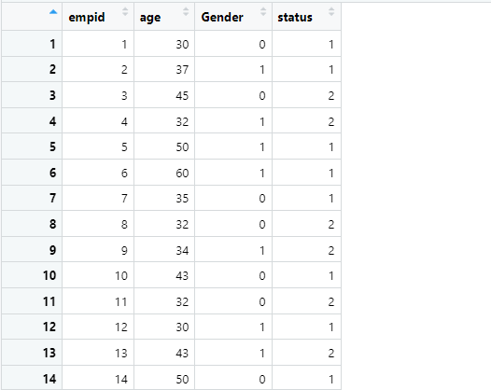

> empinfo$Gender=factor(empinfo$Gender, labels=c("male","female")) #giving the labels
> empinfo$status=factor(empinfo$status, labels=c("staff","faculty"))
> empinfo
empid age Gender status
1 1 30 male staff
2 2 37 female staff
3 3 45 male faculty
4 4 32 female faculty
5 5 50 female staff
6 6 60 female staff
7 7 35 male staff
8 8 32 male faculty
9 9 34 female faculty
10 10 43 male staff
11 11 32 male faculty
12 12 30 female staff
13 13 43 female faculty
14 14 50 male staff
15 15 60 male faculty
> View(empinfo)

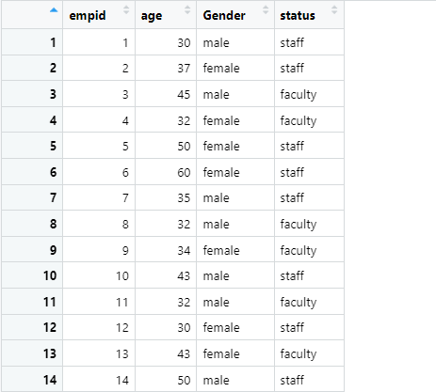

> Genderm= subset(empinfo, empinfo$Gender=='male') #creating the subset from empinfo
> Genderm # info about male gender only
empid age Gender status
1 1 30 male staff
3 3 45 male faculty
7 7 35 male staff
8 8 32 male faculty
10 10 43 male staff
11 11 32 male faculty
14 14 50 male staff
15 15 60 male faculty

> #CREATING ONE-WAY TABLE
> tab1 = table(empinfo$age) # frequency table
> tab1

30 32 34 35 37 43 45 50 60
2 3 1 1 1 2 1 2 2
> tab2 = table(empinfo$Gender)
> tab2

male female
8 7
> View(tab1)
> View(tab2)

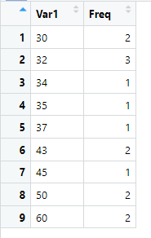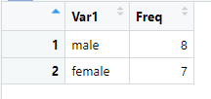

> #CREATING TWO-WAY TABLE
> tab3 = table(empinfo$Gender, empinfo$status)
> tab3

staff faculty
male 4 4
female 4 3
> #GRAPHICAL REPRESENTATION IN R
>
> # 1.PLOT
> plot(empinfo$age, type="b", main="age of subjects",
xlab="empid", ylab="age in years",col="red")
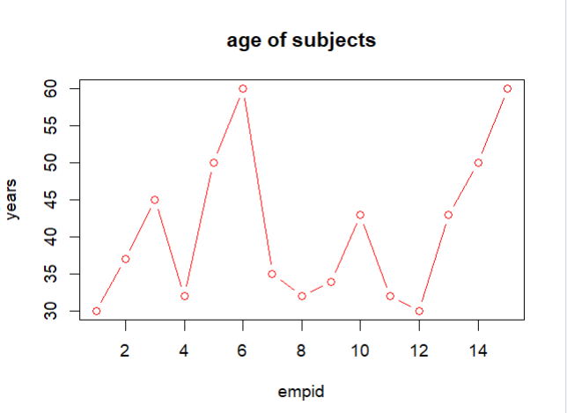
> # 2.PIE CHART
> pie(tab2, labels = c("male", "female"),
main = "pie chart for gender", col = c("blue","red"))
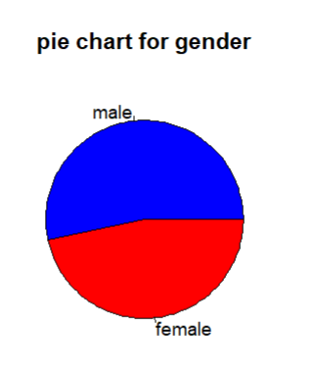
> # 3.BAR PLOT
> barplot(tab3, beside=T, xlim=c(1,15), ylim=c(0,5),
col=c("blue","red"), legend=rownames(tab3))
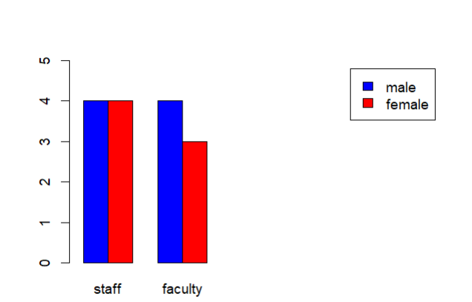
> # 4.BOX PLOT
> boxplot(empinfo$age~empinfo$Gender, main="Box plot,
xlab="Gender", ylab="Age",col=c("red","blue"))
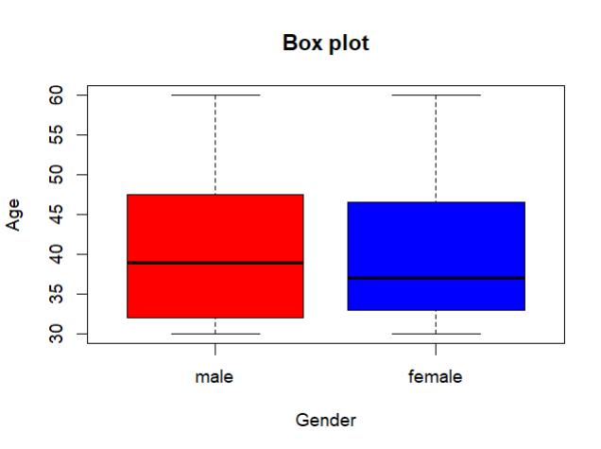

#PRACTICE QUESTIONS
> #Q1
> tab4=table(empinfo$status)
> barplot(tab4, beside=T, xlim=c(1,15), ylim=c(0,10),
col=c("blue","red"), legend=rownames(tab4))
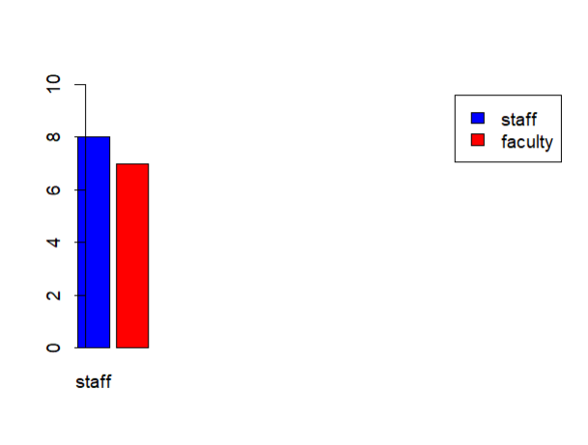
> #Q2
> boxplot(empinfo$age~empinfo$Gender, main="Box plot",
xlab="Gender", ylab="Age",col=c("red","blue"))
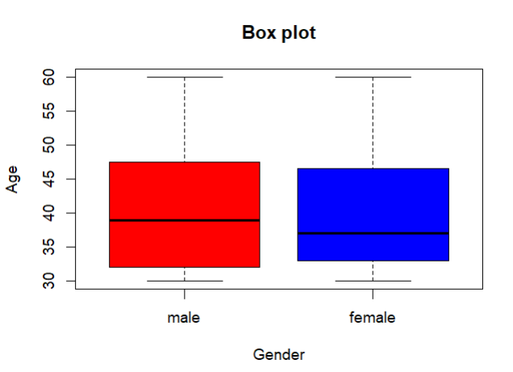
> #Q3
> x=c(1,2,3,4,5,6,7,8,9)
> plot(x,x**2,type="l",col="red")
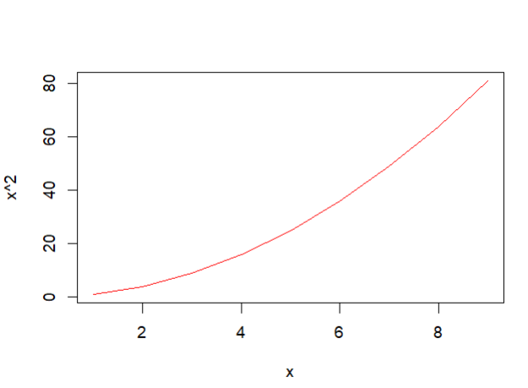
> #Q4
> plot(x,log(x),col='orange',type='s')
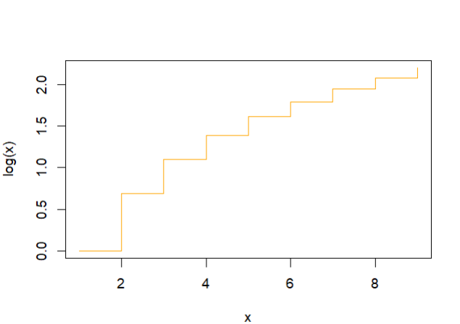
> #Q5
> temp=c(67 ,72 ,74 ,62 ,76 ,66 ,65 ,59 ,61 ,69 )
> hist(temp,col='blue',main='Temprature',
xlab='Temprature',ylab='Frequency')
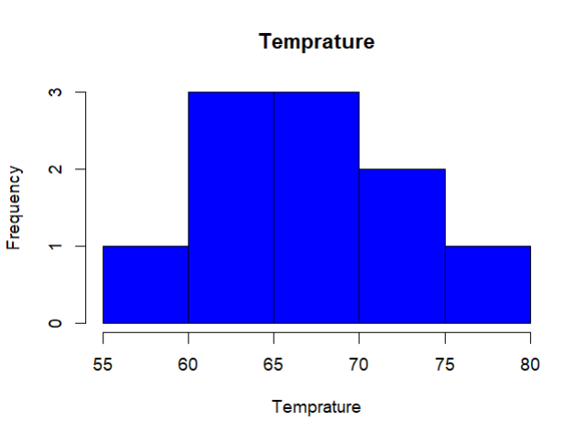

PRACTICAL4
AIM : Simulate random outcomes and calculate probabilities for the
case of coin flips and card draws.
- Random Event: A random event is an event that can not be
predicted or is unpredictable at the beginning of an
experiment.
Example:- Dice, coin toss ,card draw etc
- Probability:- Probability is the measure of the possible
outcomes of an event. It is defined as a number between 0
and 1 (0 denoting improbability and 1 denoting certainty).
P(X) = (Number of favourable outcomes)/ (Total number of outcomes in sample space)

- COIN FLIP
When flipping a fair coin, there are two possible outcomes: heads (H) and tails (T).
The probability of each outcome is:
• P(H) = 1⁄2
• P(T) = 1⁄2
Simulation: If we flip a coin 10 times, we can calculate the
probabilities of getting a certain number of heads or tails.
P(X = k) = (n k) p^{k}(1-p)^{n-k}
Where:
n = total flips, k = number of heads, p = probability of heads (0.5)

#COIN FLIP
> n_flips=10 #no. of times the coin is flipped
> n_simulations=8 #total
> set.seed(123)
> result=replicate(n_simulations,sum(sample(c(0,1),n_flips,
replace=TRUE)))
> result
[1] 4 5 4 4 3 4 3 5
> table(result)
result
3 4 5
2 4 2

> probabilities=table(result)/n_simulations
> probabilities
result
3 4 5
0.25 0.50 0.25

> probabilities=as.data.frame(probabilities)
> probabilities
result Freq
1 3 0.25
2 4 0.50
3 5 0.25

> colnames(probabilities)=c("No. of heads","Probability")
> print(probabilities)
No. of heads Probability
1 3 0.25
2 4 0.50
3 5 0.25

> View(probabilities)
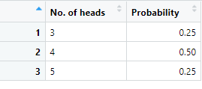

- CARD DRAW
When drawing a card from a standard deck of 52 cards,
there are 52 possible outcomes.
The probabilities can be calculated for
specific events, such as drawing a heart or an ace.
• Probability of drawing a heart: P(Heart) = 13/52 = 1⁄4 = 0.25
• Probability of drawing an ace: P(Ace) = 4/52 = 1/13 ≈ 0.0769
Simulation: If we simulate drawing 10 cards from a deck (without
replacement), we can calculate probabilities for various outcomes. For
example, if we want to know the probability of drawing exactly 3 hearts
in 10 draws, we can again use the hypergeometric distribution:
P(X = k) =[(K k)(N−K n−k)]/(N n)
Where:
• N = total cards (52)
• K = total hearts (13)
• n = total draws (10)
• k = desired number of hearts (3)

> #CARD DRAW
> n_draws=10
> n_simulations=15
> draw_card=function(){
+ deck=rep(c("Heart","Diamond","Club","Spade"),
times=c(13,13,13,13))
+ drawn=sample(deck,n_draws,replace=FALSE)
+ return(sum(drawn=="Heart"))
+ }
> set.seed(123)
> heart_counts=replicate(n_simulations,draw_card())
> heart_counts
[1] 1 4 2 3 4 0 2 3 1 3 2 0 1 3 4
> table(heart_counts)
heart_counts
0 1 2 3 4
2 3 3 4 3
> heart_probabilities=table(heart_counts)/n_simulations
> heart_probabilities=as.data.frame(heart_probabilities)
> heart_probabilities
heart_counts Freq
1 0 0.1333333
2 1 0.2000000
3 2 0.2000000
4 3 0.2666667
5 4 0.2000000
> colnames(heart_probabilities)=c("Number of Hearts","Probability")
> print(heart_probabilities)
Number of Hearts Probability
1 0 0.1333333
2 1 0.2000000
3 2 0.2000000
4 3 0.2666667
5 4 0.2000000
> View(heart_probabilities)

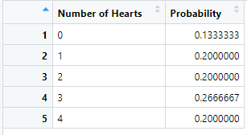

PRACTICAL5
AIM: Simulate experimental probabilities and compare it with
theoretical probabilities.
1. Theoretical Probability: Theoretical probability is the
expected outcome based on the total number of possible
outcomes.
It’s calculated using the formula:
P(A) = (Number of favorable outcomes) /(Total number of outcomes)
2. Experimental Probability : Experimental probability is
calculated based on the actual outcomes of an experi3.ment.
It’s given by the formula:
P(E) = (Number of times event E occurs) /(Total number of trials)

> #ROLLING DIE
> n_die_rolls=100
> die_rolls=sample(1:6,n_die_rolls,replace=TRUE) #simulate the die rolls(1to6)

> table(die_rolls)
die_rolls
1 2 3 4 5 6
14 16 16 18 13 23

> experimental_die_probability=table(die_rolls)/n_die_rolls
> theoretical_die_probability=rep(1/6,6)

> cat("Experimental probabilities for die rolls:\n")
Experimental probabilities for die rolls:
> print(experimental_die_probability)
die_rolls
1 2 3 4 5 6
0.14 0.16 0.16 0.18 0.13 0.23

> cat("\nTheoretical probabilities for die rools:\n")

Theoretical probabilities for die rools:
> print(theoretical_die_probability)
[1] 0.1666667 0.1666667 0.1666667 0.1666667 0.1666667 0.1666667

> # COMBINING BOTH INTO A DATA FRAME FOR COMPARISON
> comparision=data.frame(
+ Side=1:6,
+ Theoretical_Probabilty=theoretical_die_probability,
+ Experiment_Probability=as.numeric(experimental_die_probability)
+ )

> comparision
Side Theoretical_Probabilty Experiment_Probability
1 1 0.1666667 0.14
2 2 0.1666667 0.16
3 3 0.1666667 0.16
4 4 0.1666667 0.18
5 5 0.1666667 0.13
6 6 0.1666667 0.23
> View(comparision)

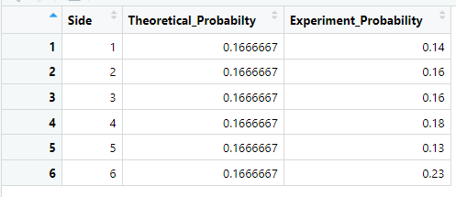

> # COMPARE IN A BARPLOT
> barplot(
+ rbind(theoretical_die_probability,experimental_die_probability),
+ beside=TRUE,
+ col=c("red","yellow"),
+ legend=c("Theoretical","Experimental"),
+ names.arg=1:6,
+ main="Theoretical vs Experimental Probabilities for Die Rolls"
+ )

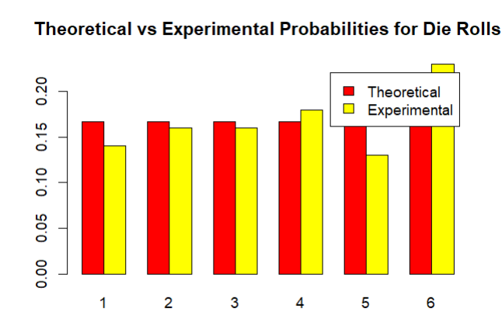

PRACTICE QUESTIONS

- Q1. Run the code to simulate experimental probabilities of Drawing
a Card from Deck and compare it with theoretical probabilities.
Also compare in barplot.

> set.seed(456)
> deck=rep(c("Hearts","Diamonds","Clubs","Spades"),each=13)
> n_card_draws=100
> draw_cards=sample(deck,n_card_draws,replace=TRUE)
> table(draw_cards)
draw_cards
Clubs Diamonds Hearts Spades
27 31 22 20
> experimental_card_probabilty=table(draw_cards)/n_card_draws
> theoretical_card_probability=rep(1/4,4)
> cat("Experimental probabilities for drawing cards:\n")
Experimental probabilities for drawing cards:
> print(experimental_card_probabilty)
draw_cards
Clubs Diamonds Hearts Spades
0.27 0.31 0.22 0.20
> cat("\nTheoretical probabilities for drawing cards:\n")

Theoretical probabilities for drawing cards:
> print(theoretical_card_probability)
[1] 0.25 0.25 0.25 0.25

> #BAR PLOT
>theoretical_card_probability=as.numeric(theoretical_card_probability)
> experimental_card_probability=as.numeric(experimental_card_probability)

> barplot(
+ rbind(theoretical_card_probability, experimental_card_probability),
+ beside=TRUE,
+ col=c("orange", "green"),
+ legend.text=c("Theoretical", "Experimental"),
+ names.arg=c("Hearts", "Diamonds", "Clubs", "Spades"),
+ main="Theoretical vs Experimental Probabilities for Drawing Cards")
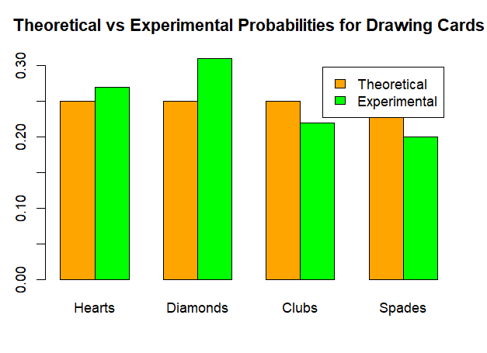

- Q2. After setting seed to 1234 , Run the code to simulate
experimental probabilities of Coin Flip and compare it with
theoretical probabilities.
a). Also compare in barplot.
b). Compare in line graph.
c). Combine both into a data frame for comparison and View
table.

> set.seed(1234)
> flips=rep(c('Heads','Tails'),each=1)
> n_flips=10
> coin_flip=sample(flips,n_flips,replace=TRUE)

> table(coin_flip)
coin_flip
Heads Tails
4 6

> experimental_flip_probability=table(coin_flip)/n_flips
> theoretical_flip_probability=rep(1/2,2)

> cat("Experimental probabilities for flipping coin:\n")
Experimental probabilities for flipping coin:
> print(experimental_flip_probability)
coin_flip
Heads Tails
0.4 0.6
> cat("\nTheoretical probabilities for flipping coins:\n")
Theoretical probabilities for flipping coins:
> print(theoretical_flip_probability)
[1] 0.5 0.5

> #BAR PLOT

>experimental_flip_probability=as.numeric(experimental_flip_probability)
> theoretical_flip_probability=as.numeric(theoretical_flip_probability)

> barplot(
+ rbind(theoretical_flip_probability, experimental_flip_probability),
+ beside=TRUE,
+ col=c("pink", "blue"),
+ legend.text=c("Theoretical", "Experimental"),
+ names.arg=c("Heads","Tails"),
+ main="Theoretical vs Experimental Probabilities for Flipping Coins")

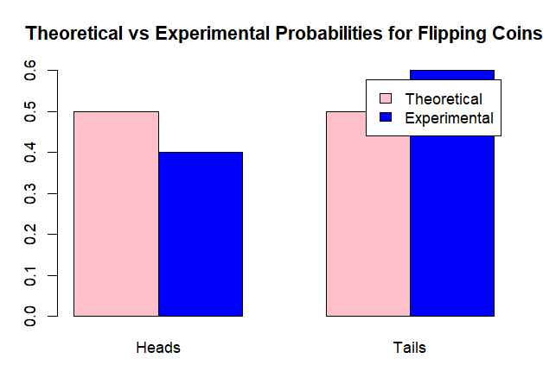

> # Combine probabilities into a data frame for plotting
> outcome <- c("Heads", "Tails")
> prob_data <- data.frame(
+ Outcome = outcome,
+ Experimental = experimental_flip_probability,
+ Theoretical = theoretical_flip_probability
+ )
> View(prob_data)

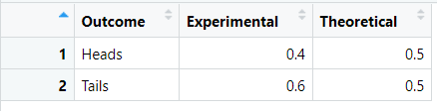
> # Plot line graph
> plot(
+ 1:2, prob_data$Experimental, type = "o", col = "blue",
+ ylim = c(0, 1), ylab = "Probability", xlab = "Outcome",
+ main = "Line Plot of Experimental vs Theoretical Probabilities",
+ xaxt = "n"
+ )
> axis(1, at = 1:2, labels = prob_data$Outcome)
> lines(1:2, prob_data$Theoretical, type = "o", col = "red")
> legend("topright", legend = c("Experimental", "Theoretical"),
+ col = c("blue", "red"), lty = 1)
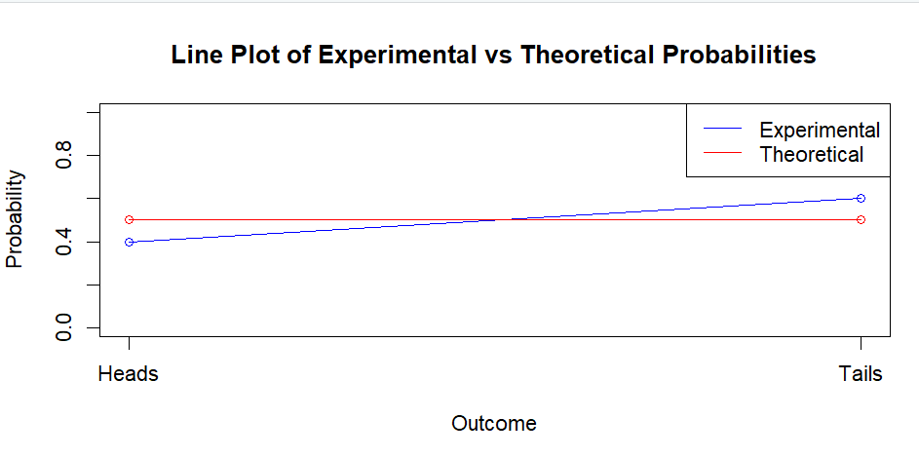

> View(prob_data)
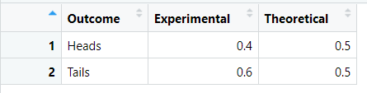

PRACTICAL6
Aim : Calculate expected value and variance in the context of single random variable.
Description
There are two main types of random variables:
1. Discrete Random Variable: Takes on a countable number of distinct values. For
example, the number of heads in a series of coin flips.
a) Expected Value (E[X]): is a measure of the central tendency of a random variable. It
represents mean of the possible values that a random variable can take, weighted by their probabilities.
It's calculated by summing the products of each value and its probability:
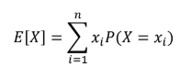
where x_{I} are the possible values of the random variable X and P(X = x_{I}) is the probability of X taking the value x_{I}
b) Variance (Var(X)): measures the spread or dispersion of a random variable's possible
values around the expected value. It quantifies how much the values of the random variable differ from the expected value. A higher variance indicates greater variability in the values.
Variance is calculated as the expected value of the squared deviation of a random variable from its mean:
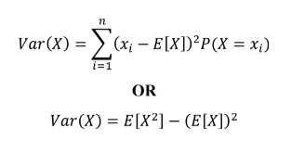Where,
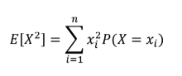
2. Continuous Random Variable: Takes on an infinite number of possible values within
a given range. For example, the height of individuals in a population.
a) Expected Value (E[X]): It's calculated by integrating the product of the value and its
probability density function over the entire range.
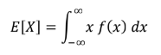
where f(x) is the probability density function (PDF) of the random variable X.
b) Variance (Var(X)):
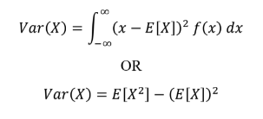Where,
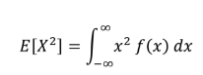

> #PROBABILITY DISTRIBUTION FOR DISCRETE RANDOM VARIABLE

> x=c(1,2,3)
> p=c(0.2,0.5,0.3)
> expected_value=sum(x*p)
> variance=sum((x-expected_value)^2*p)

> expected_value
[1] 2.1
> variance
[1] 0.49

>marks=c(14,17,25,14,21,17,19,18,26,18,17,17,26,19,21,21,25,14,19)
> freq_table=table(marks)
> prob_distribution=freq_table/length(marks)
> prob_distribution
marks
14 17 18 19 21 25 26
0.1578947 0.2105263 0.1052632 0.1578947 0.1578947 0.1052632 0.1052632

>mean_x=sum(as.numeric(names(prob_distribution))*prob_distribution)
> variance_x=sum(((as.numeric(names(prob_distribution))-mean_x)^2)*prob_distribution)
> sd_x=sqrt(variance_x)

> mean_x
[1] 19.36842
> variance_x
[1] 14.33795
> sd_x
[1] 3.786549

> #PROBABILITY DISTRIBUTION FOR CONTINUOUS RANDOM VARIABLE
> pdf=function(x) {
+ ifelse(x>=0 & x<=1, 2*x,
+ ifelse(x>1 & x<=2, 2*(2-x),0))
+ }

>expected_value=integrate(function(x)x*pdf(x),lower=0,upper=2)$value
>expected_value_sq=integrate(function(x)x^2*pdf(x),lower=0,upper=2)$value
> variance_x=expected_value_sq - expected_value^2

> expected_value
[1] 2
> variance_x
[1] -1.666667

#PRACTICE QUESTION

- Q1. Consider a discrete random variable X with the following possible
values and their corresponding probabilities:
Values: 0, 3, 5, 10
Probabilities: 0.2, 0.1, 0.1, 0.6
Calculate the expected value E[X] and variance Var[X] of the random variable.

> values=c(0,3,5,10)
> probabilities=c(0.2,0.1,0.1,0.6)

> expected_value=sum(values*probabilities)
> variance=sum((values-expected_value)^2*probabilities)

> cat("Expected Value (E[X]):", expected_value, "\n")
Expected Value (E[X]): 6.8
> cat("Variance (Var(X)):", variance, "\n")
Variance (Var(X)): 17.16

- Q2. Consider X as a random variable representing the outcome of rolling a fair six-sided die. Calculate the expected value and variance of the random variable.

> outcomes <- 1:6
> probabilities=rep(1/6, 6)

> expected_value=sum(outcomes * probabilities)
> expected_value_sq=sum((outcomes^2) * probabilities)
> variance=expected_value_sq - (expected_value)^2

> cat("Expected Value (E[X]):", expected_value, "\n")
Expected Value (E[X]): 3.5
> cat("Variance (Var(X)):", variance, "\n")
Variance (Var(X)): 2.916667

- Q3.Consider a continuous random variable X with probability density function:
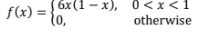
Find expected value and variance of X.

> pdf=function(x) {
+ ifelse(x>0 & x<1, 6*x*(1-x),0)
+ }

>expected_value=integrate(function(x)x*pdf(x),lower=0,upper=1)$value
>expected_value_sq=integrate(function(x)x^2*pdf(x),lower=0,upper=1)$value
> variance_x=expected_value_sq - expected_value^2

> cat("Expected Value (E[X]):", expected_value, "\n")
Expected Value (E[X]): 0.5
> cat("Variance (Var(X)):", variance, "\n")
Variance (Var(X)): 2.916667

PRACTICAL7 AIM : Generate and plot probabilities for events in discrete and continuous distributions
(Binomial, Poisson, Geometric, and Normal).
Description
- BINOMIAL DISTRIBUTION
The binomial distribution is a discrete probability distribution that models the number of successes in a fixed number of independent trials of a binary experiment. Each trial can result in one of two outcomes: "success" or "failure."
1. Number of Trials (n): The total number of independent trials or experiments.
2. Probability of Success (p): The probability of success in a single trial.
3. Probability of Failure (q): The probability of failure in a single trial, calculated as q = 1 − p.
4. Random Variable (X): Represents the number of successes in n trials.
Probability Mass Function (PMF)
The probability of observing exactly k successes (where k can range from 0 to n) in n trials isgiven by the binomial probability mass function:
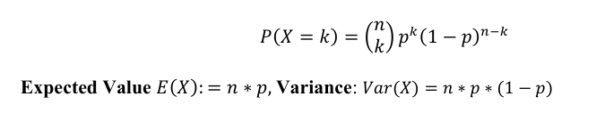
1. dbinom(x, size, prob) : This function gives the probability density distribution at each point.
2. pbinom(x, size, prob, lower.tail = TRUE) : This function gives the cumulative probability of an event.
- lower.tail: If TRUE (default), probabilities are P(X ≤ q); if FALSE, P(X > q).

> #BINOMIAL DISTRIBUTION

> dbinom(3,size=10,prob=0.5)
[1] 0.1171875
> pbinom(3,size=10,prob=0.5,lower.tail=F)
[1] 0.828125
> sum(dbinom(4:10,size=10,prob=0.5))
[1] 0.828125

> #Probability P(X=k),where k is ranging from 1-10
> x_binomial=1:10
> x_binomial
[1] 1 2 3 4 5 6 7 8 9 10
> px_binomial=dbinom(x_binomial,size=10,prob=0.5)
> px_binomial
[1] 0.0097656250 0.0439453125 0.1171875000 0.2050781250 0.2460937500 0.2050781250 0.1171875000 0.0439453125 0.0097656250
[10] 0.0009765625

> #Probability distribution and plot
> df1=data.frame(Number_Success=x_binomial,Probability=px_binomial)
> df1
Number_Success Probability
1 1 0.0097656250
2 2 0.0439453125
3 3 0.1171875000
4 4 0.2050781250
5 5 0.2460937500
6 6 0.2050781250
7 7 0.1171875000
8 8 0.0439453125
9 9 0.0097656250
10 10 0.0009765625

> barplot(px_binomial,names.arg= x_binomial,
+ main="Binomial Distribution (n=10, p=0.5)",
+ xlab= "Number of Successes",
+ ylab="Probability",
+ col="lightblue")

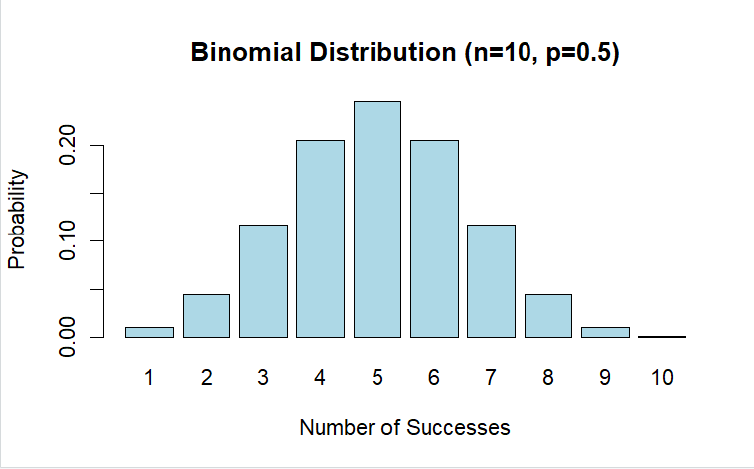

> #Calculate cumulative probabilities for 0 to 20 defective widgets
> k_values=0:5
> cum_prob= pbinom(k_values, size=5, prob=0.05, lower.tail=T)

> #Create a data frame for plotting
> df2=data.frame(k=k_values, CDF=cum_prob)
> df2
k CDF
1 0 0.7737809
2 1 0.9774075
3 2 0.9988419
4 3 0.9999700
5 4 0.9999997
6 5 1.0000000

> barplot(cum_prob,
+ names.arg= k_values,
+ col="orange",
+ main="CDF of Defective Widgets",
+ xlab= "Number of DEfective Widgets",
+ ylab="Cumulative Probability",
+ ylim=c(0,1))
>

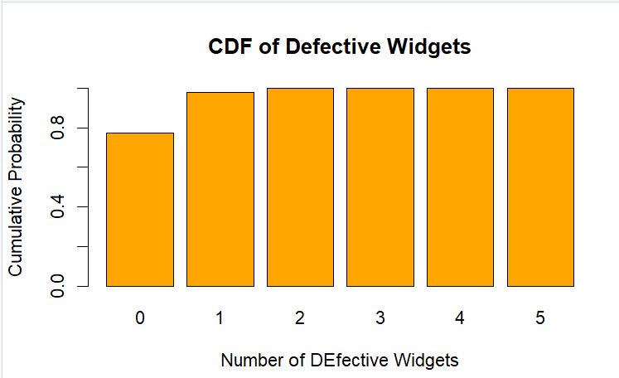
- POISSON DISTRIBUTION
The Poisson distribution is a discrete probability distribution that expresses the probability of agiven number of events occurring continuously but within a fixed interval of time or space,given that these events occur with a known constant mean rate and are independent of the time since the last event. We call it the distribution of rare events.
1. Parameter (λ): The average number of events in the given interval. It is also the mean and variance of the distribution.
2. Events: The events must occur independently. That is, the occurrence of one event does not affect the occurrence of another.
3. Interval: The interval can be time, space, or any other measurable quantity.
4. For a small interval, the probability of the event occurring is proportional to the size of the interval.
5. The probability of more than one occurrence in the small interval is negligible.
Probability Mass Function (PMF)
The probability of observing k events in an interval is given by the formula:
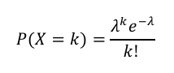
where
k is the actual number of events (0, 1, 2, ...)., e is Euler's number (approximately 2.71828), λ is the average number of events.
Expected Value: λ, Variance: λ
1. dpois(x, lambda, log) - the probability of x successes in a period when the expected
number of events is lambda
2. ppois(q, lambda, lower.tail = TRUE, log.p = FALSE)- the cumulative probability of less
than or equal to q successes.

- log: A logical value. If TRUE, the function returns the logarithm of the probability;
if FALSE (the default), it returns the actual probability.
- lower.tail: If TRUE (default), probabilities are P(X ≤ q); if FALSE, P(X > q).
> #Calculate the probability of receiving exactly 5 events when average number of events is 3
> prob_exactly_5=dpois(5,3)
> prob_exactly_5
[1] 0.1008188

> #Calculate the log of the probability of receiving exactly 5 events
> log_prob_exactly_5=dpois(5,3,log=TRUE)
> log_prob_exactly_5
[1] -2.29443

> #P(X>2) with lambda 3
> 1-ppois(2,3)
[1] 0.5768099

> #Example1
> lambda=4
> k=2
> prob_exactly_2=dpois(k,lambda)
> prob_exactly_2
[1] 0.1465251
> k_values=0:10
> pmf_values=dpois(k_values,lambda)

> barplot(pmf_values,
+ names.arg=k_values,
+ col="pink",
+ main="Poisson Distribution PMF (lambda=4)",
+ xlab="Number of Books",
+ ylab= "Probability",
+ ylim=c(0,max(pmf_values)*1.1))
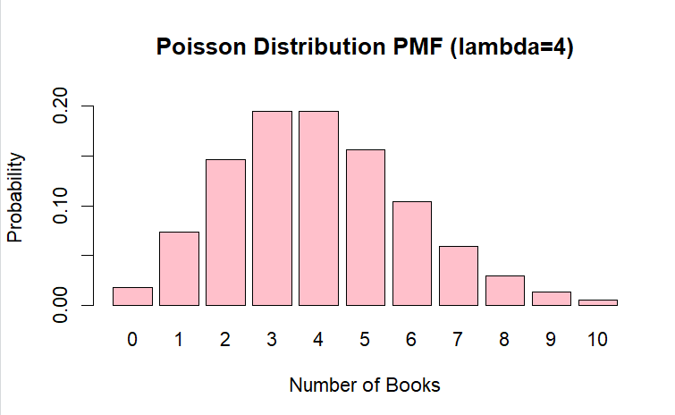

> #Example2
> par(mfrow=c(2,2))
> x=0:10
> plot(x,dpois(x,2),xlab="Number of Hits",ylab="P(X=x)",
+ type="h",main="Web Site Hits: Poisson(2)")
> plot(x,dpois(x,2),xlab="Number of Calls",ylab="P(X=x)",
+ type="h",main="Calls to mobile: Poisson(3)")
> plot(x,dpois(x,2),xlab="Number of Submission",ylab="P(X=x)",
+ type="h",main="Job Submissions: Poisson(4)")
> plot(x,dpois(x,2),xlab="Number of Messages",ylab="P(X=x)",
+ type="h",main="Mesages to Server: Poisson(2)")

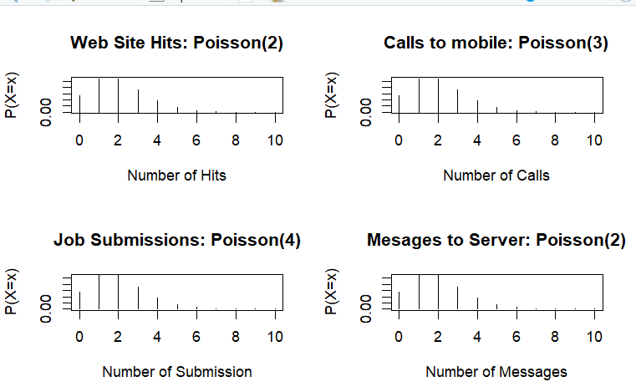

- GEOMETRIC DISTRIBUTION
The geometric distribution is a discrete probability distribution that models the number of trials
required to achieve the first success in a sequence of independent Bernoulli trials (where each
trial has two possible outcomes: success or failure). It is particularly useful in scenarios where
you want to determine how many attempts it takes before the first success occurs.
1. Parameter (p): The probability of success on each trial.
2. Trials: Each trial is independent, meaning the outcome of one trial does not affect the
others.
Probability Mass Function (PMF)
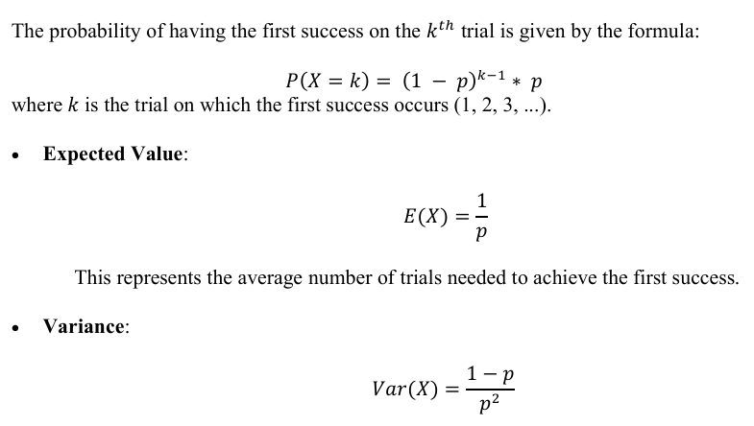
This represents the average number of trials needed to achieve the first success.

1. dgeom(x, prob, log = FALSE): Calculates the probability of having exactly x failures
before the first success.
2. pgeom(q, prob, lower.tail = TRUE, log.p = FALSE): Calculates the probability of
having at most q failures before the first success.
> #pmf: Probability of exactly 3 failures
> prob_3_failures=dgeom(3,0.2)
> prob_3_failures
[1] 0.1024
> #cdf: Probability of at most 3 failures
> prob_atmost_3_failures=pgeom(3,0.2)
> prob_atmost_3_failures
[1] 0.5904
> #Number of trials
> trials=0:9
> pmf_values=dgeom(trials,0.2)
> pmf_table=data.frame(Number_of_failures=trials,Probability=pmf_values)
> pmf_table
Number_of_failures Probability
1 0 0.20000000
2 1 0.16000000
3 2 0.12800000
4 3 0.10240000
5 4 0.08192000
6 5 0.06553600
7 6 0.05242880
8 7 0.04194304
9 8 0.03355443
10 9 0.02684355
> #Create a bar plot for the pmf
> barplot(pmf_values,
+ names.arg=trials,
+ main="Probability Mass Function of the Goeometric Distriibution",
+ xlab="Number of Failures",
+ ylab="Probability",
+ col="yellow",
+ border="red")
>

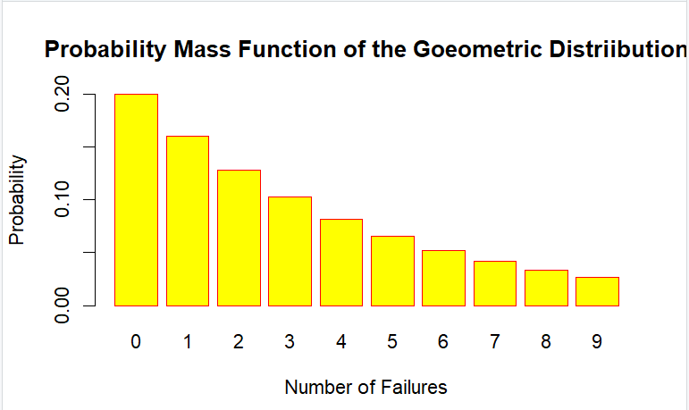
- NORMAL DISTRIBUTION
The normal distribution, also known as the Gaussian distribution, is a continuous probability distribution that is symmetric about its mean, indicating that data near the mean are more frequent in occurrence than data far from the mean.
1. Bell-Shaped Curve: The graph of the normal distribution is bell-shaped and symmetric around the mean. In the graph, fifty percent of values lie to the left of the mean and the other fifty percent lie to the right of the graph.
2. Mean (μ): The central value of the distribution, which is also its median and mode.
3. Standard Deviation (σ): A measure of the dispersion or spread of the distribution. It determines the width of the bell curve.
4. Notation: A normal distribution is often denoted as where μ is the mean andσ²
Probability Density Function (PDF)
The probability density function of a normal distribution is given by:
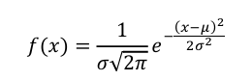
Properties
1. Symmetry: The distribution is symmetric about the mean.
2. 68-95-99.7 Rule: Approximately:
o 68% of the data falls within one standard deviation (μ ± σ).
o 95% falls within two standard deviations (μ ± 2σ).
o 99.7% falls within three standard deviations (μ ± 3σ).
3. Asymptotic: The tails of the distribution approach the horizontal axis but never touch it.

1. dnorm(x, mean = 0, sd = 1, log = FALSE): This function returns the density of the normal distribution for a given value
2. pnorm(q, mean = 0, sd = 1, lower.tail = TRUE, log.p = FALSE): This function gives the cumulative probability up to a given value.
> #Create a sequence of numbers between -10&+10 increment by 0.1
> x=seq(-10,+10,by=0.1)
> y=dnorm(x,mean=2.5,sd=0,5)
> z=pnorm(x,mean=2.5,sd=0.5)

> png(file="dnorm.png")
> plot(x,y)
> png(file="pnorm.png")
> plot(x,z)
> dev.off()
RStudioGD
2
> (pnorm(72,mean=70,sd=5)-pnorm(69,mean=70,sd=5))*1000
[1] 234.6815
> (pnorm(69,mean=70,sd=5))*1000
[1] 420.7403
> (pnorm(72,mean=70,sd=5,lower.tail=F))*1000
[1] 344.5783

> x=seq(60-4*15,60+4*15,length=1000)
> y=dnorm(x,mean=60,sd=15)
> plot(x,y,type='l',main="Normal Distribution(mean=60,sd=15)",xlab='x',
ylab='Density',lwd=2)
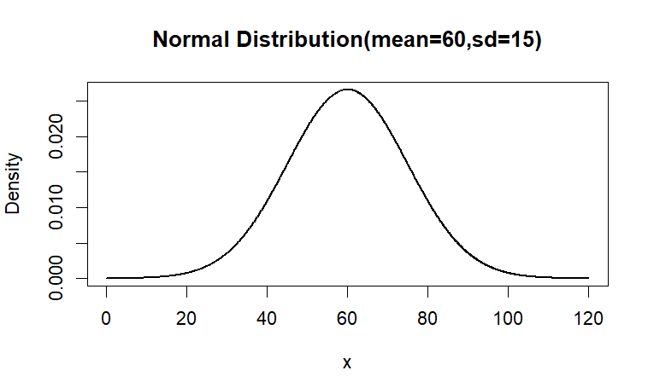
> cutoff=qnorm(0.80,mean=60,sd=15)
> x_fill=seq(cutoff,60+4*15,length=100)
> y_fill=dnorm(x_fill,mean=60,sd=15)
> plot(seq(0, 120, length = 100), dnorm(seq(0, 120, length = 100), mean = 60, sd = 15),
+ type = "l", ylab = "Density", xlab = "Score")
> polygon(c(cutoff,x_fill),c(0,y_fill),col="red",border=NA)
> text(cutoff+2,0.02,"Top 20%",col="orange")
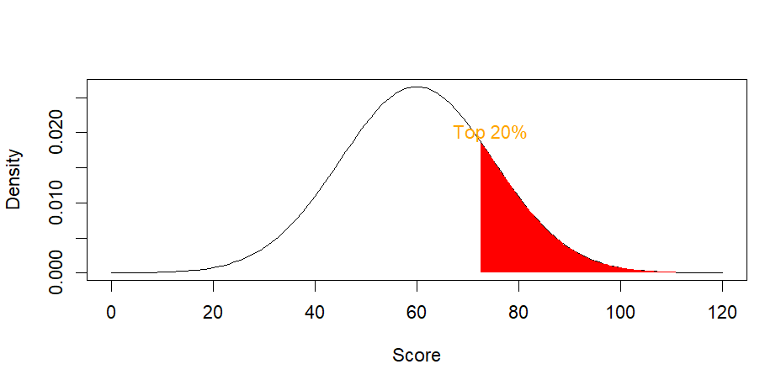

> x_fill=seq(60-15,60+15,length=100)
> y_fill=dnorm(x_fill,mean=60,sd=15)
>plot(seq(0,100,length=100),dnorm(seq(0,100,length=100),mean=60,sd=15),
+type="l",ylab="Density")
> polygon(c(60-15,x_fill,60+15),c(0,y_fill,0),col="yellow",border="black")
> text(cutoff+2,0.02,"Middle 68%",col="black")
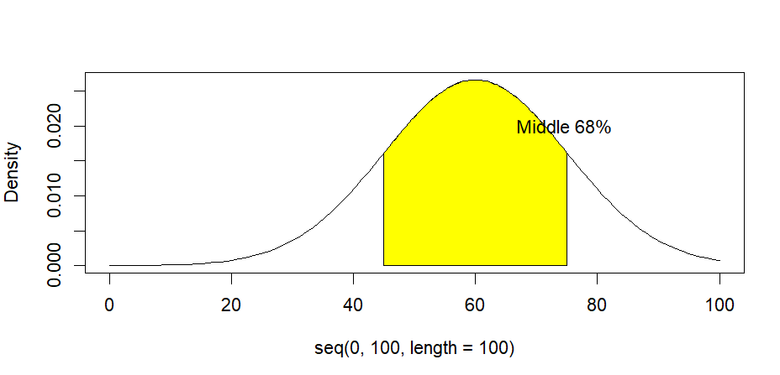
PRACTICE QUESTIONS
- Q1. A factory produces light bulbs, and the probability that a light bulb is defective is 0.1. If a quality control inspector randomly selects 15 light bulbs, what is the probability that 3 or fewer of them are defective? Also prepare pdf and cdf tables.
> defect_prob=0.1
> n_bulbs=15

> #find P(X≤3)
> probability_3_or_fewer= pbinom(3, size = n_bulbs, prob = defect_prob)
> cat("Probability of 3 or fewer defective bulbs:", probability_3_or_fewer)
Probability of 3 or fewer defective bulbs: 0.9444444

> # PDF and CDF
> x=0:n_bulbs
> pdf= dbinom(x, size = n_bulbs, prob= defect_prob)
> cdf= pbinom(x, size = n_bulbs, prob= defect_prob)
> pdf_table=data.frame(Defective_Bulbs = x, PDF = pdf)
> print(pdf_table)
Defective_Bulbs PDF
1 0 2.058911e-01
2 1 3.431519e-01
3 2 2.668959e-01
4 3 1.285054e-01
5 4 4.283515e-02
6 5 1.047081e-02
7 6 1.939040e-03
8 7 2.770056e-04
9 8 3.077841e-05
10 9 2.659862e-06
11 10 1.773241e-07
12 11 8.955765e-09
13 12 3.316950e-10
14 13 8.505000e-12
15 14 1.350000e-13
16 15 1.000000e-15
> cdf_table=data.frame(Defective_Bulbs = x, CDF = cdf)
> print(cdf_table)
Defective_Bulbs CDF
1 0 0.2058911
2 1 0.5490430
3 2 0.8159389
4 3 0.9444444
5 4 0.9872795
6 5 0.9977503
7 6 0.9996894
8 7 0.9999664
9 8 0.9999972
10 9 0.9999998
11 10 1.0000000
12 11 1.0000000
13 12 1.0000000
14 13 1.0000000
15 14 1.0000000
16 15 1.0000000

- Q2. Consider a computer system with Poisson job-arrival stream at an average of 2 per minute.
Determine the probability that in any one-minute interval there will be
- 0 jobs
- Exactly 3 jobs
- at most 3 arrivals
- between 2 to 4 arrivals
> #job-arrival stream=λ=2 per minute.
> lambda=2 # average rate

> # (i) Probability of 0 jobs
> p_0_jobs= dpois(0, lambda)
> cat("Probability of 0 jobs:", p_0_jobs)
Probability of 0 jobs: 0.1353353

> # (ii) Probability of exactly 3 jobs
> p_3_jobs= dpois(3, lambda)
> cat("Probability of exactly 3 jobs:", p_3_jobs)
Probability of exactly 3 jobs: 0.180447

> # (iii) Probability of at most 3 arrivals (P(X ≤ 3))
> p_at_most_3= ppois(3, lambda)
> cat("Probability of at most 3 arrivals:", p_at_most_3)
Probability of at most 3 arrivals: 0.8571235

> # (iv) Probability of 2 to 4 arrivals (P(2 ≤ X ≤ 4))
> p_2_to_4= ppois(4, lambda) - ppois(1, lambda)
> cat("Probability of 2 to 4 arrivals:", p_2_to_4)
Probability of 2 to 4 arrivals: 0.5413411

- Q3. A new online game has a 60% success rate for players achieving a high score on their first attempt.
- Calculate the probability that a player will succeed in achieving their first high score after exactly 4 unsuccessful attempts.
- If the game allows players to keep trying until they succeed, what is the expected number of attempts a player will make before achieving their first high score.
- Additionally, what is the probability that a player will succeed within the first 6 attempts?
> success_rate=p=0.60
> failure_rate=q=1-p

> # (i) Probability of first high score after exactly 4 unsuccessful attempts
> p_4_attempts= dgeom(4, prob = success_rate)
> cat("Probability of success after exactly 4 unsuccessful attempts:", p_4_attempts)
Probability of success after exactly 4 unsuccessful attempts: 0.01536

> # (ii) Expected number of attempts to achieve the first high score
> expected_attempts= 1 / p
> cat("Expected number of attempts before the first high score:", expected_attempts)
Expected number of attempts before the first high score: 1.666667

> # (iii) Probability of succeeding within the first 6 attempts (P(X ≤ 6))
> p_within_6 = pgeom(5, prob = p)
> cat("Probability of success within the first 6 attempts:", p_within_6)
Probability of success within the first 6 attempts: 0.995904

- Q4. In a test on 2000 Electric bulbs ,it was found that the life of particular make, was normally distributed with an average life of 2040 hours and S.D of 60 hours. Estimate the number of bulbs likely to burn for:
- More than 2150 hours
- Less than 1950 hours
- More than 1920 hours but less than 2160 hours
- More than 2150 hours
> tot_bulbs=2000
> avg_life=2040
> sd=60

> # (i) More than 2150 hours (P(X > 2150))
> p_more_than_2150 = 1 - pnorm(2150, mean=2040, sd =60 )
> bulbs_more_than_2150 = tot_bulbs * p_more_than_2150
> cat("Bulbs likely to burn more than 2150 hours:", bulbs_more_than_2150, "\n")
Bulbs likely to burn more than 2150 hours: 66.75302

> # (ii) Less than 1950 hours (P(X < 1950))
> p_less_than_1950= pnorm(1950, mean = 2040, sd = 60)
> bulbs_less_than_1950= tot_bulbs * p_less_than_1950
> cat("Bulbs likely to burn less than 1950 hours:", bulbs_less_than_1950, "\n")
Bulbs likely to burn less than 1950 hours: 133.6144

> # (iii) More than 1920 hours but less than 2160 hours (P(1920 < X < 2160))
> p_between_1920_2160= pnorm(2160, mean = 2040, sd = 60) - pnorm(1920, mean = 2040, sd = 60 )
> bulbs_between_1920_2160= tot_bulbs * p_between_1920_2160
> cat("Bulbs likely to burn between 1920 and 2160 hours:", bulbs_between_1920_2160)
Bulbs likely to burn between 1920 and 2160 hours: 1908.999

> # (iv) More than 2150 hours (same as part i)
> cat("Bulbs likely to burn more than 2150 hours:", bulbs_more_than_2150)
Bulbs likely to burn more than 2150 hours: 66.75302

PRACTICAL8
AIM: Applying the t-test for independent and dependent samples.
DESCRIPTION: The t-test is a statistical test used to determine if there is a significant
difference between the means of two groups. It’s commonly used in hypothesis testing and
comes in several forms, each with specific applications.
TYPES OF T-TEST:
- Independent Samples t-test (Two-Sample t-test): Compares the means of two
unrelated groups to see if they differ significantly.
- 2. Paired Samples t-test (Dependent t-test): Compares means from the same group at
two different times or two matched groups to see if there’s a significant change.

HYPOTHESES IN A T-TEST
For each type, we set up null (H0) and alternative (H1) hypotheses:
• Null Hypothesis (H0): There is no significant difference between the means.
• Alternative Hypothesis (H1): There is a significant difference between the means.

FORMULA:
1. Independent Samples t-test (Two-Sample t-test)
The independent samples t-test compares the means of two independent groups. The formula
for the t-statistic in the independent t-test is:
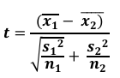
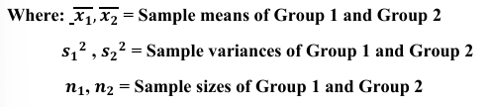
- INDEPENDENT SAMPLES T-TEST (TWO-SAMPLE T-TEST)
- t.test(group_A, group_B): Conducts a t-test comparing group_A and group_B.
- var.equal = TRUE: Assumes equal variances between groups.
- set var.equal = FALSE, if variances are unequal.
> #SAMPLE DATA FOR 2 INDEPENDENT GROUPS
> groupA=c(85,88,90.78,82)
> groupB=c(78,80,83,76,79)
> t_test_independent=t.test(groupA,groupB,var.equal=TRUE)
> t_test_independent

Two Sample t-test

data: groupA and groupB
t = 3.4188, df = 7, p-value = 0.01115
alternative hypothesis: true difference in means is not equal to 0
95 percent confidence interval:
2.234026 12.255974
sample estimates:
mean of x mean of y
86.445 79.200

2. Paired Samples t-test (Dependent t-test)
The paired samples t-test is used when the samples are dependent, such as before-and-after measurements. The formula for the t-statistic in the paired t-test is:
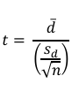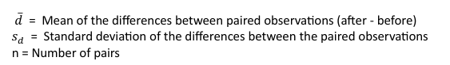
ASSUMPTIONS: The differences between the paired observations are normally distributed.
Degrees of freedom (df): df = n−1 Where n is the number of paired observations.

- PAIRED SAMPLES T-TEST (DEPENDENT TEST)
- t.test(before, after, paired = TRUE): Conducts a paired t-test comparing before and after measurements.
- paired = TRUE: Specifies that the data are paired (dependent).
- Summary Table for Choosing the Right t-test

> #SAMPLE DATA FOR 2 PAIRED (DEPENDENT) GROUPS
> before=c(75,80,85,90,95)
> after=c(78,82,88,92,96)
> t_test_dependent=t.test(before,after,paired=TRUE)
> t_test_dependent

Paired t-test

data: before and after
t = -5.8797, df = 4, p-value = 0.004181
alternative hypothesis: true mean difference is not equal to 0
95 percent confidence interval:
-3.238851 -1.161149
sample estimates:
mean difference
-2.2

INTEPRATATION OF RESULT
For each t-test, the output includes:
• t-value: Indicates the size of the difference relative to the variation in the data.
• p-value: A p-value < 0.05 (or your chosen significance level) indicates a statistically
significant difference.
• Confidence Interval (CI): Shows the range within which the true mean difference
likely lies.
• Mean Difference: The estimated difference between means (relevant for paired and
two-sample t-tests).

PRACTICE QUESTIONS
- Q1.Suppose you are testing the effectiveness of two teaching methods on student performance. You have two groups of students, each taught with a different method.Test whether there is a significant difference between the two groups' average scores.
Method1: 78, 82, 84, 88, 90, 85, 87, 89, 90, 80
Method2: 75, 79, 81, 83, 78, 80, 82, 84, 85, 77
> #PRACTICE QUESTIONS
> method1=c(78, 82, 84, 88, 90, 85, 87, 89, 90, 80)
> method2=c(75, 79, 81, 83, 78, 80, 82, 84, 85, 77)
> t.test(method1,method2,var.equal=TRUE)

Two Sample t-test

data: method1 and method2
t = 2.9139, df = 18, p-value = 0.009263
alternative hypothesis: true difference in means is not equal to 0
95 percent confidence interval:
1.36709 8.43291
sample estimates:
mean of x mean of y
85.3 80.4
- Q2: You want to check the effectiveness of a new learning app by measuring the same students' scores before and after using it. Test if there is a significant improvement in scores after using the app.
Before: 65, 68, 70, 72, 66, 75, 67, 69, 71, 68
After: 70, 72, 75, 78, 70, 80, 73, 75, 78, 74
> before=c(65, 68, 70, 72, 66, 75, 67, 69, 71, 68)
> after=c(70, 72, 75, 78, 70, 80, 73, 75, 78, 74)
> t.test(before,after,paired=TRUE)

Paired t-test

data: before and after
t = -17.676, df = 9, p-value = 2.692e-08
alternative hypothesis: true mean difference is not equal to 0
95 percent confidence interval:
-6.0911 -4.7089
sample estimates:
mean difference
-5.4

PRACTICAL9
AIM: Fit simple linear regression models using built-in functions.
LINEAR REGRESSION: A linear regression is a statistical model that analyses the relationship between a response variable/dependent variable (often called y) and one predictor variables (often called x or explanatory variables) and their interactions using a regression line.
Linear Regression Equation is y=ax+b , where a is slope and b is intercept.
- Example: when we calculate the age of a child based on their height, we assumed how older they are, the taller they will be. In this particular example, you can calculate the height of a child if you know her/his age: Height=a+Age*b . The slope measures the change in height with respect to the age in months (or years). In general, for every month older the child is, their height will increase with b.
R - MULTIPLE REGRESSION: Multiple regression is an extension of linear regression into relationship between more than two variables. In simple linear relation we have one predictor and one response variable, but in multiple regression we have more than one predictor variable and one response variable.
The general mathematical equation for multiple regression is : y = a + b₁x₁ + b₂x₂ +...+b_{n}x_{n}
where : y is the response variable. a, b1, b2,...,bn are the coefficients. x1, x2, ..., xn are the predictor variables.

REAL WORLD APPLICATIONS: (Why are you studying this model)
1. Predicting house prices based on features like size, location, etc.
2. Estimating sales revenue based on advertising spend.
3. Analyzing relationships between biological or environmental variables.
4. Analyzing relationships between Mid-term marks and End-term marks.

COMMANDS AND CALCULATION OF R: Basic steps to perform Linear Regression in R
1. Use the lm() function to fit a linear model : The model lm() determines the value of the coefficients using the input data. Next we can predict the value of the response variable for a given set of predictor variables using these coefficients. model <- lm(Y ~ X, data = dataset)
Y is the dependent variable, X is the independent variable, and data is the data frame containing the variable you want to study.
2. Check the Model Summary: The summary() function provides detailed information on the model, including coefficients, R-squared, and p-values. summary(model)
• Coefficients: The estimated values for the intercept and the slope.
• R-squared: A measure of how well the model explains the variance in the data.
• p-values: To test the significance of the coefficients.
• Residual standard error: A measure of the typical size of the residuals.

3. Plot the Model : A quick visualization of the model fit can be achieved using plot().
plot(dataset$X, dataset$Y)
abline(model, col = "blue")
abline() - Adds the regression line to the plot.

> #EXAMPLE1
> data("mtcars")
> View(mtcars)
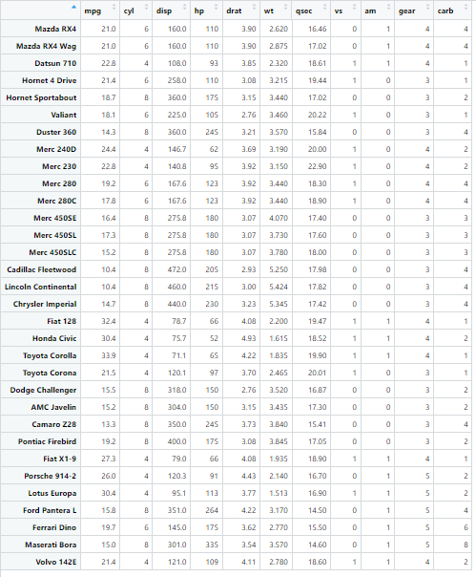
> str(mtcars)
'data.frame': 32 obs. of 11 variables:
$ mpg : num 21 21 22.8 21.4 18.7 18.1 14.3 24.4 22.8 19.2 ...
$ cyl : num 6 6 4 6 8 6 8 4 4 6 ...
$ disp: num 160 160 108 258 360 ...
$ hp : num 110 110 93 110 175 105 245 62 95 123 ...
$ drat: num 3.9 3.9 3.85 3.08 3.15 2.76 3.21 3.69 3.92 3.92 ...
$ wt : num 2.62 2.88 2.32 3.21 3.44 ...
$ qsec: num 16.5 17 18.6 19.4 17 ...
$ vs : num 0 0 1 1 0 1 0 1 1 1 ...
$ am : num 1 1 1 0 0 0 0 0 0 0 ...
$ gear: num 4 4 4 3 3 3 3 4 4 4 ...
$ carb: num 4 4 1 1 2 1 4 2 2 4 ...

> plot(mtcars$wt,mtcars$mpg,main="MPG vs Weight",xlab="Weight(1000 lbs)",
ylab="Miles Per Gallon",col=c("red","darkgreen"))
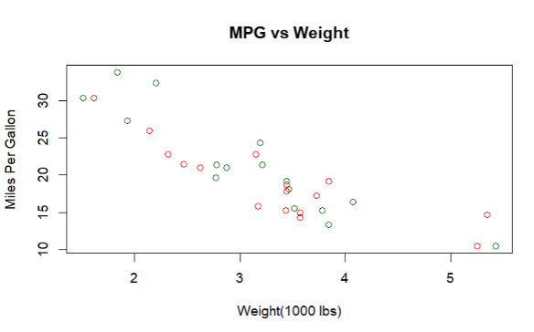
> model=lm(mpg~wt,data=mtcars)
> summary(model)

Call:
lm(formula = mpg ~ wt, data = mtcars)

Residuals:
Min 1Q Median 3Q Max
-4.5432 -2.3647 -0.1252 1.4096 6.8727

Coefficients:
Estimate Std. Error t value Pr(>|t|)
(Intercept) 37.2851 1.8776 19.858 < 2e-16 ***
wt -5.3445 0.5591 -9.559 1.29e-10 ***
---
Signif. codes: 0 ‘***’ 0.001 ‘**’ 0.01 ‘*’ 0.05 ‘.’ 0.1 ‘ ’ 1

Residual standard error: 3.046 on 30 degrees of freedom
Multiple R-squared: 0.7528, Adjusted R-squared: 0.7446
F-statistic: 91.38 on 1 and 30 DF, p-value: 1.294e-10

> abline(model,col="blue")
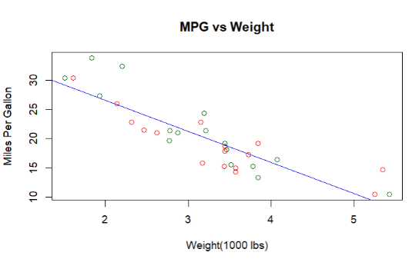

> #EXAMPLE2
> x= c(151,174,138,186,128,136,179,163,152,131)
> y= c(63,81,56,91,47,57,76,72,62,48)
> relation=lm(x~y)
> relation

Call:
lm(formula = x ~ y)

Coefficients:
(Intercept) y
61.380 1.415

> summary(relation)

Call:
lm(formula = x ~ y)

Residuals:
Min 1Q Median 3Q Max
-6.0529 -2.4833 -0.0912 1.3774 10.0562

Coefficients:
Estimate Std. Error t value Pr(>|t|)
(Intercept) 61.3803 7.2653 8.448 2.94e-05 ***
y 1.4153 0.1089 12.997 1.16e-06 ***
---
Signif. codes: 0 ‘***’ 0.001 ‘**’ 0.01 ‘*’ 0.05 ‘.’ 0.1 ‘ ’ 1

Residual standard error: 4.712 on 8 degrees of freedom
Multiple R-squared: 0.9548, Adjusted R-squared: 0.9491
F-statistic: 168.9 on 1 and 8 DF, p-value: 1.164e-06

> cor(x,y)
[1] 0.9771296
> plot(y,x,main="Height & Weight Regression",xlab="Weight(in Kg)",
ylab="Height(in cm)",col=c("red","darkgreen"))
> abline(lm(x~y),col="blue")
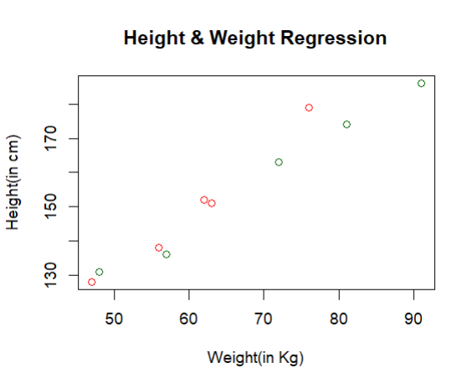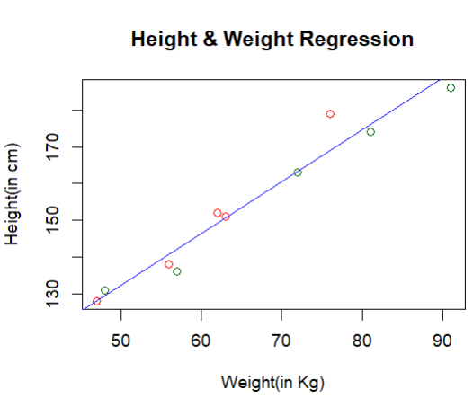

PRACTICE QUESTIONS
- Q1.The mtcars dataset in R contains various attributes of different car models, such as miles per gallon (mpg), horsepower (hp), weight (wt), and more. Your task is to predict the fuel efficiency (mpg) of cars based on their weight (wt) and horsepower (hp).
> data(mtcars)
> model= lm(mpg ~ wt + hp, data = mtcars)
> summary(model)

Call:
lm(formula = mpg ~ wt + hp, data = mtcars)

Residuals:
Min 1Q Median 3Q Max
-3.941 -1.600 -0.182 1.050 5.854

Coefficients:
Estimate Std. Error t value Pr(>|t|)
(Intercept) 37.22727 1.59879 23.285 < 2e-16 ***
wt -3.87783 0.63273 -6.129 1.12e-06 ***
hp -0.03177 0.00903 -3.519 0.00145 **
---
Signif. codes: 0 ‘***’ 0.001 ‘**’ 0.01 ‘*’ 0.05 ‘.’ 0.1 ‘ ’ 1

Residual standard error: 2.593 on 29 degrees of freedom
Multiple R-squared: 0.8268, Adjusted R-squared: 0.8148
F-statistic: 69.21 on 2 and 29 DF, p-value: 9.109e-12

> new_data=data.frame(wt = 3.0, hp = 150)
> predicted_mpg=predict(model, newdata = new_data)
> predicted_mpg
1
20.82784

- Q2. Fit a linear model for inbuilt data-women like mtcars.
> data(women)
> model_women=lm(weight~height,data=women)
> new_data_women=data.frame(height = 65)
> predicted_weight=predict(model_women, newdata = new_data_women)
> print(predicted_weight)
1
136.7333
> summary(model_women)

Call:
lm(formula = weight ~ height, data = women)

Residuals:
Min 1Q Median 3Q Max
-1.7333 -1.1333 -0.3833 0.7417 3.1167

Coefficients:
Estimate Std. Error t value Pr(>|t|)
(Intercept) -87.51667 5.93694 -14.74 1.71e-09 ***
height 3.45000 0.09114 37.85 1.09e-14 ***
---
Signif. codes: 0 ‘***’ 0.001 ‘**’ 0.01 ‘*’ 0.05 ‘.’ 0.1 ‘ ’ 1

Residual standard error: 1.525 on 13 degrees of freedom
Multiple R-squared: 0.991, Adjusted R-squared: 0.9903
F-statistic: 1433 on 1 and 13 DF, p-value: 1.091e-14

